**ICP10**

ICP Group 4

Name: Sailaja Narra

Email: [sntnn@umsystem.edu](mailto:sntnn@umsystem.edu)

ICP Report: [https://drive.google.com/file/d/1AHu01JAtMF9vZYqNC7gQqy2uCUGUqZ5H/view?usp=sharing](https://nam02.safelinks.protection.outlook.com/?url=https%3A%2F%2Fdrive.google.com%2Ffile%2Fd%2F1AHu01JAtMF9vZYqNC7gQqy2uCUGUqZ5H%2Fview%3Fusp%3Dsharing&data=04%7C01%7Csntnn%40umkc.edu%7Cee77516a5c074bcb786608d9a0d10666%7Ce3fefdbef7e9401ba51a355e01b05a89%7C0%7C0%7C637717641882078300%7CUnknown%7CTWFpbGZsb3d8eyJWIjoiMC4wLjAwMDAiLCJQIjoiV2luMzIiLCJBTiI6Ik1haWwiLCJXVCI6Mn0%3D%7C1000&sdata=elxwNw%2Bdq3jvR1AtyzaYHd13EjefPmEgk%2BMR3YNgd1I%3D&reserved=0)

ICP Video: [https://umsystem.hosted.panopto.com/Panopto/Pages/Viewer.aspx?id=b5889463-b855-4020-b886-add8002af13c](https://nam02.safelinks.protection.outlook.com/?url=https%3A%2F%2Fumsystem.hosted.panopto.com%2FPanopto%2FPages%2FViewer.aspx%3Fid%3Db5889463-b855-4020-b886-add8002af13c&data=04%7C01%7Csntnn%40umkc.edu%7Cee77516a5c074bcb786608d9a0d10666%7Ce3fefdbef7e9401ba51a355e01b05a89%7C0%7C0%7C637717641882088295%7CUnknown%7CTWFpbGZsb3d8eyJWIjoiMC4wLjAwMDAiLCJQIjoiV2luMzIiLCJBTiI6Ik1haWwiLCJXVCI6Mn0%3D%7C1000&sdata=ej7aEDb5WgZZeNO31vXhC8g7AlR6DmyQeN%2Bgvw%2FyWaQ%3D&reserved=0)

GitHub (Sourcecode): [https://github.com/UMKC-APL-WebMobileProgramming/ICP10-Mahesh68/tree/main/Source](https://nam02.safelinks.protection.outlook.com/?url=https%3A%2F%2Fgithub.com%2FUMKC-APL-WebMobileProgramming%2FICP10-Mahesh68%2Ftree%2Fmain%2FSource&data=04%7C01%7Csntnn%40umkc.edu%7Cee77516a5c074bcb786608d9a0d10666%7Ce3fefdbef7e9401ba51a355e01b05a89%7C0%7C0%7C637717641882088295%7CUnknown%7CTWFpbGZsb3d8eyJWIjoiMC4wLjAwMDAiLCJQIjoiV2luMzIiLCJBTiI6Ik1haWwiLCJXVCI6Mn0%3D%7C1000&sdata=nBicPTKNok6p%2BukrQNE2ljaTgTFXBrb6YCjrgDuRs1w%3D&reserved=0)

My Partner

• Partner: Venkata Mahesh Mokkapati

• Email: [vmzwn@umsystem.edu](mailto:vmzwn@umsystem.edu)

• Repo: [https://github.com/UMKC-APL-WebMobileProgramming/ICP10-sailajanarra](https://nam02.safelinks.protection.outlook.com/?url=https%3A%2F%2Fgithub.com%2FUMKC-APL-WebMobileProgramming%2FICP10-sailajanarra&data=04%7C01%7Csntnn%40umkc.edu%7Cee77516a5c074bcb786608d9a0d10666%7Ce3fefdbef7e9401ba51a355e01b05a89%7C0%7C0%7C637717641882098289%7CUnknown%7CTWFpbGZsb3d8eyJWIjoiMC4wLjAwMDAiLCJQIjoiV2luMzIiLCJBTiI6Ik1haWwiLCJXVCI6Mn0%3D%7C1000&sdata=NcBwQAzpnXGtLs4Nrcsy0Shur27qJS8yF%2Fx5oMNL8Ik%3D&reserved=0)

In this task we understood about the some of the aspects of android such as fetching JSON data from APIs, parsing the JSON data, handling errors, using the Async task and some JAVA elements.

Description: Rendering and displaying the recent earthquake information.

Here we have the given source code where there are enhancements that has to be done in this ICP.

1. Here internet permissions are added in the manifests file to make sure internet connectivity is possible for the third party apps/plugins.

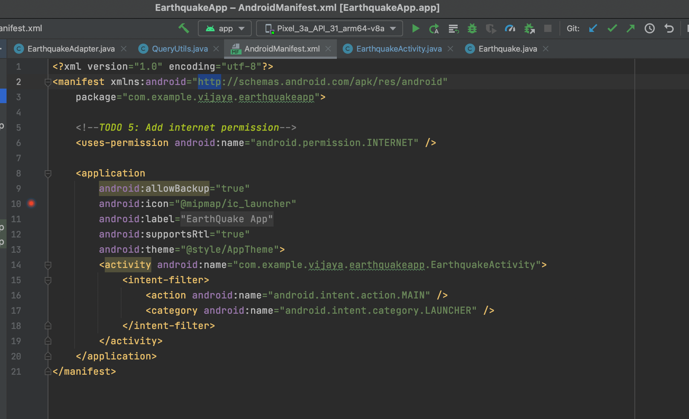

1. Here Main activity is the earthquake activity where the list of earthquakes are shown as a list.

URL for earthquake data

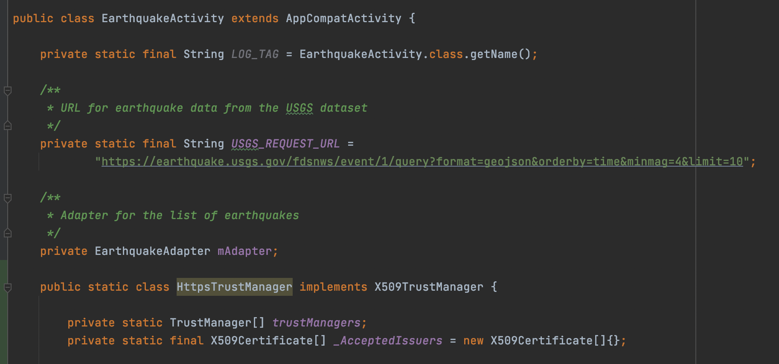

A new adapter is created for the data items. Here the adapter is used to convert data items into view items.

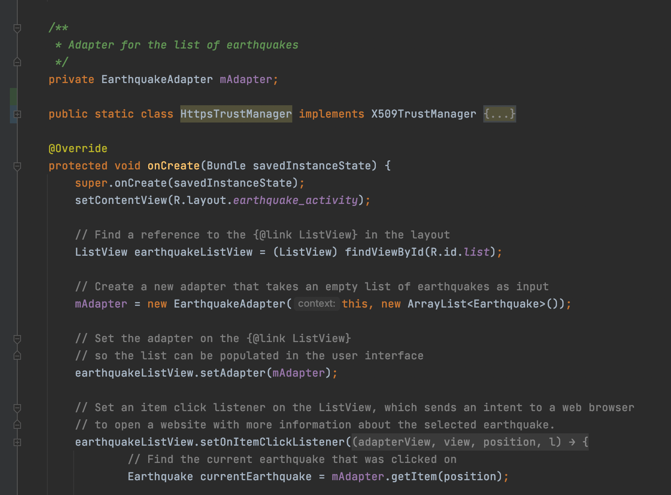

List view is created to display the list of scrollable items as shown below in the design page. This list view is passed as a second argument to the adapter in the “EarthquakeActivity.java” file.

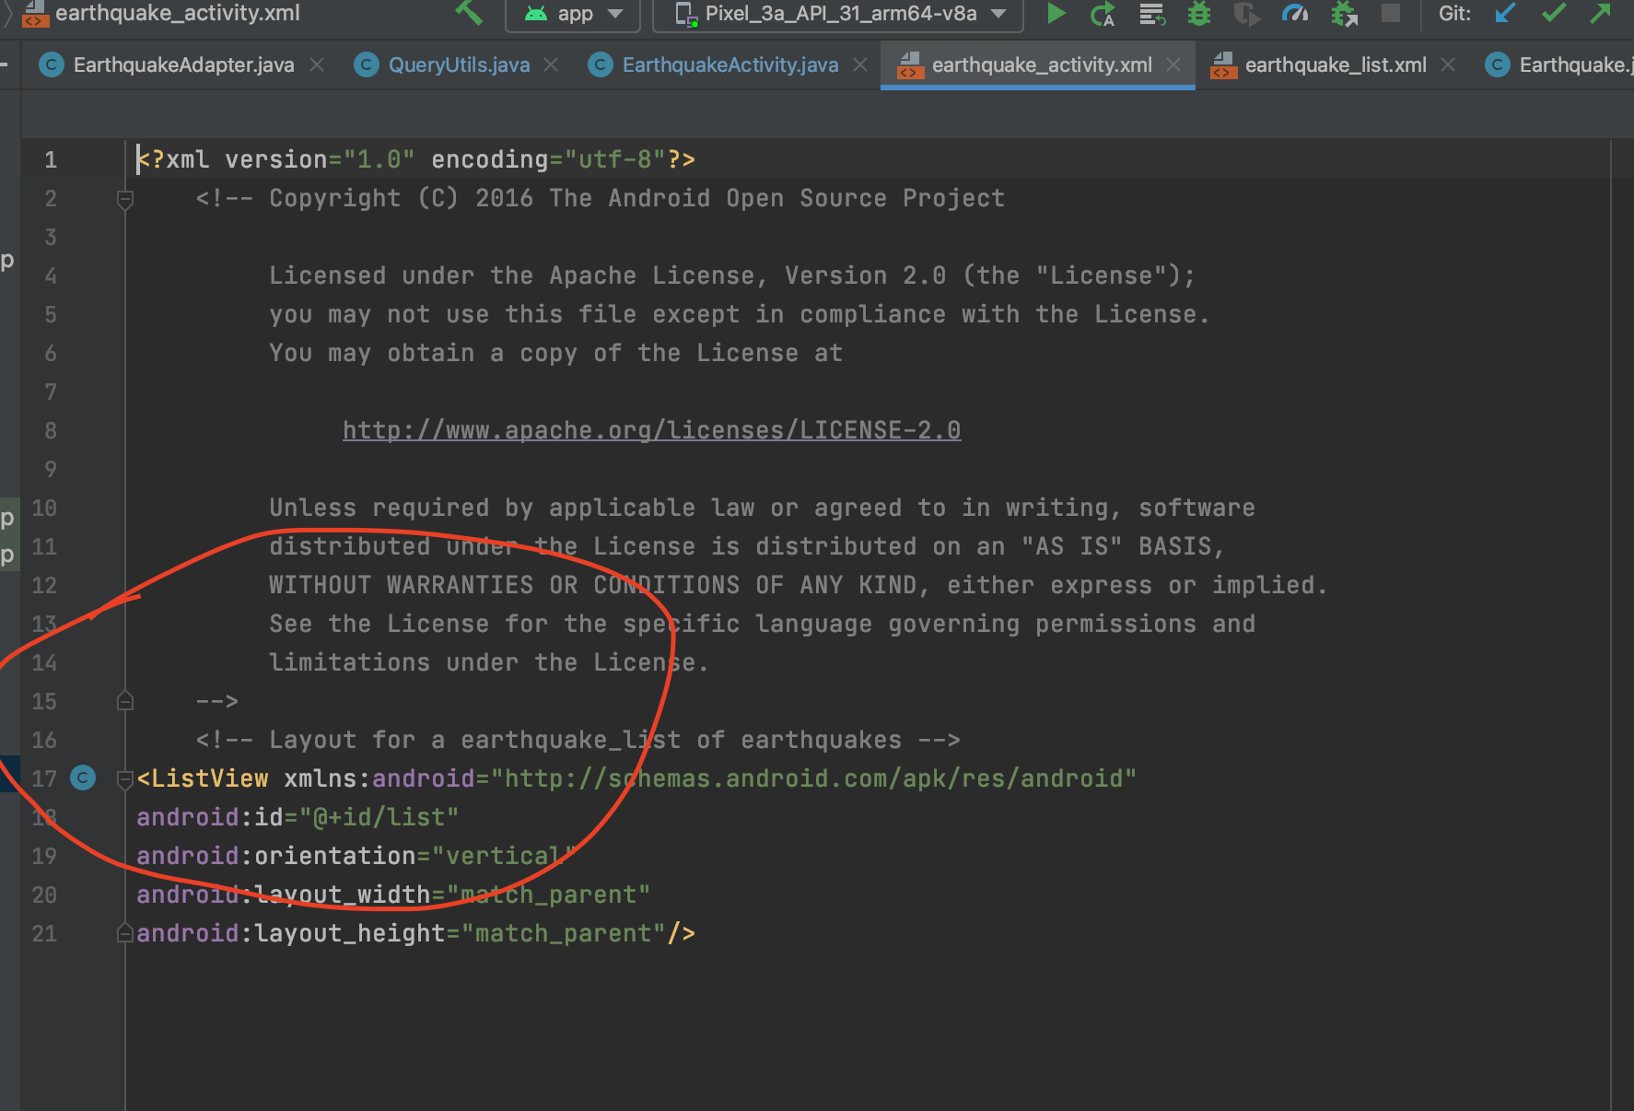

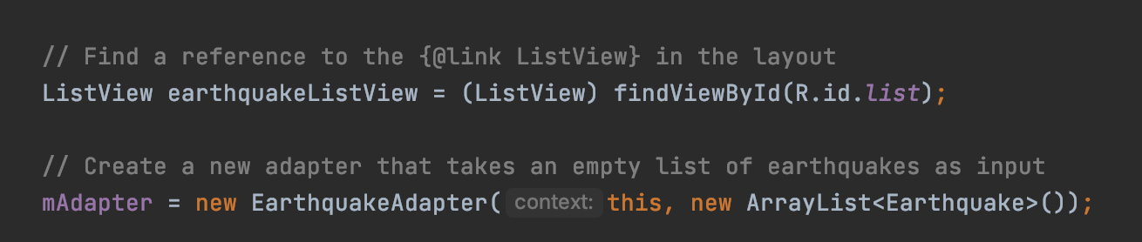

1. Now the list is populated into the user interface. Now for this list view an on click event listener is added so that it sends an intent to a web browser to open website with more information about the selected earthquake.

Taking the URI of the clicked view item and passed to the created new intent to launch a new activity.

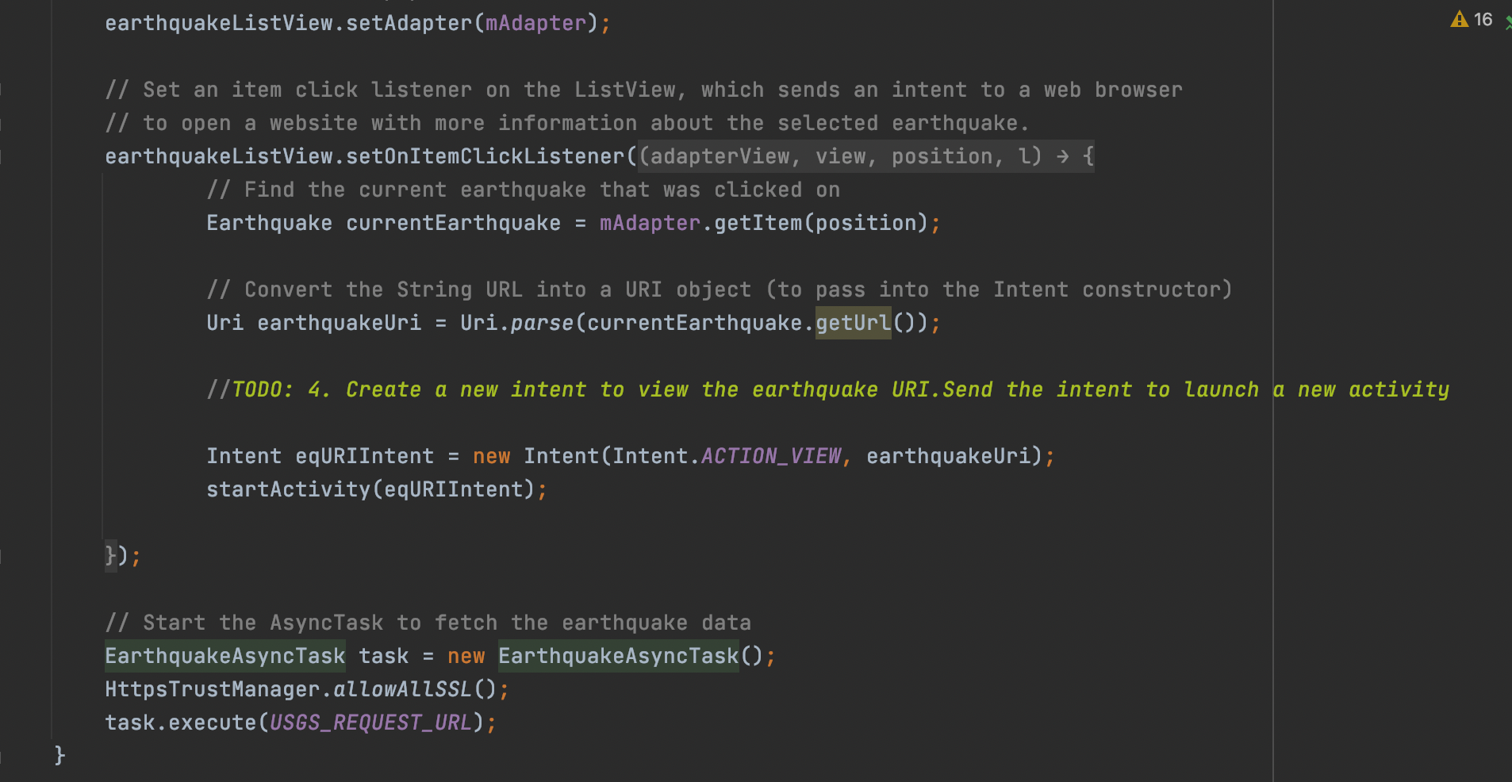

Here to perform the API call/network request Async task is used. To perform the operation in the background thread and update the UI with the list of earthquakes in the response.

Async task has three parameters as an input :

1. Input type – String “url”
2. A type used for progress updates
3. Output type – return earthquake

This async task lifecycle has three of the methods:

In this task we will override only two of the methods:

1. doInBakground – This method runs on the background thread and performs the network request. This result of earthquakes is returned to the onpostexecute method. UI will not be updated from the background thread.
2. onPostExecute – This method takes the output of background thread as an input. This method runs on the UI thread so the UI will be updated from here. Previous data will be cleared from the adapter and then updated with the list of earthquake items.

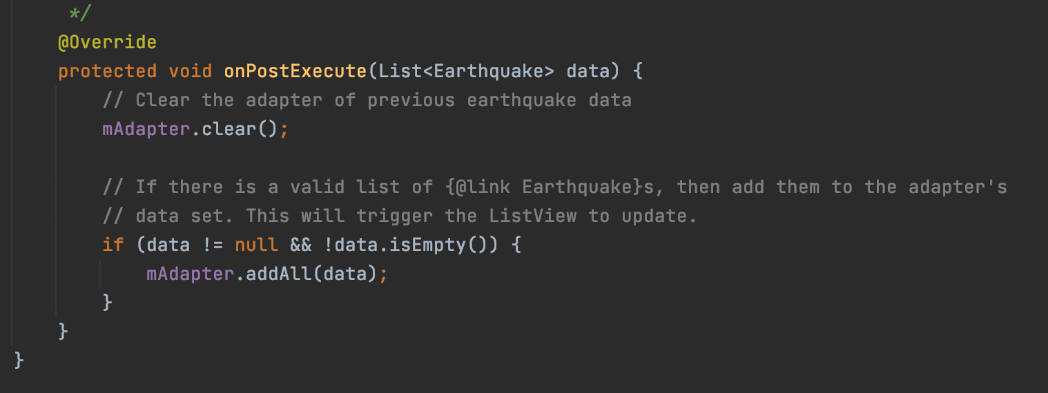

In the background thread network request is performed using the “queryutils.java”

Here a new Array list is created to store the response obtained from the REST API call.

4. Creating an URL object:

An empty variable is created to store the JSON response. An obsolute URL is created that contains all the necessary information to reach the resource.

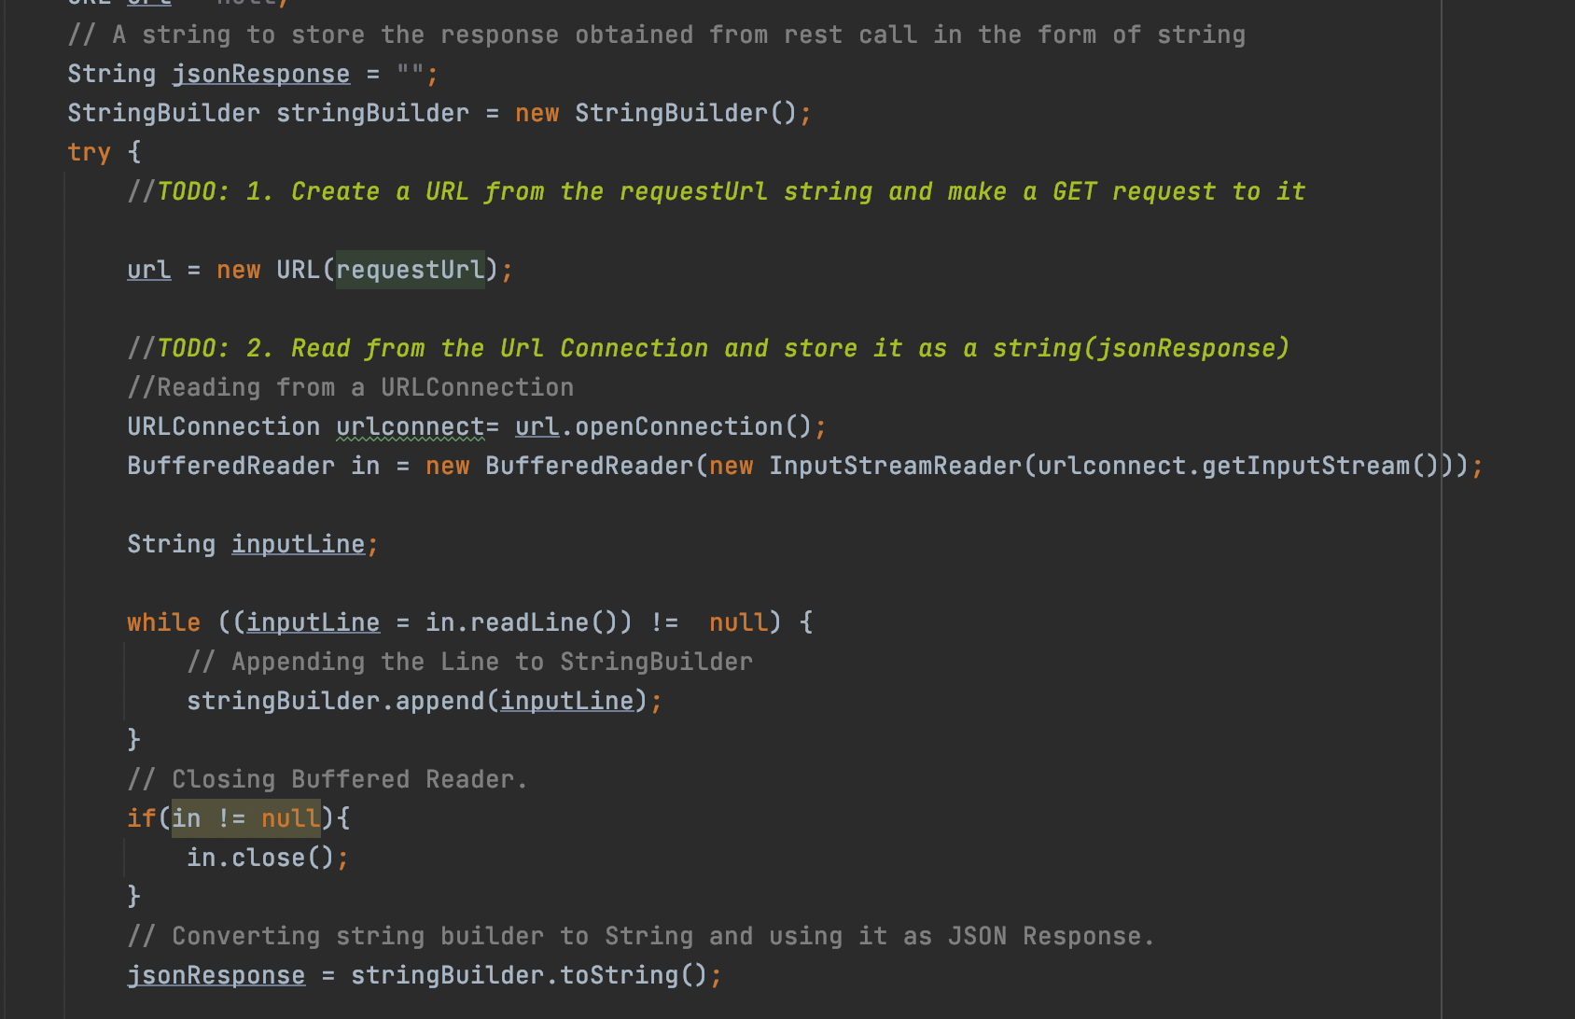

After creating the URL I make use of URL’s get input stream method to get a stream from which we can read the contents of the URL.

There is also a openStream() method which will serve the same purpose.

Here I made use of string builder to store the response of the JSON data and then converted back to string and stored in the JSON response variable that’s created.

5. The obtained JSON data is extracted to get the properties of “mag”, “place”, “time”, “url” for every earthquake.

Created corresponding earthquake items and added each object to the earthquake list and returned.

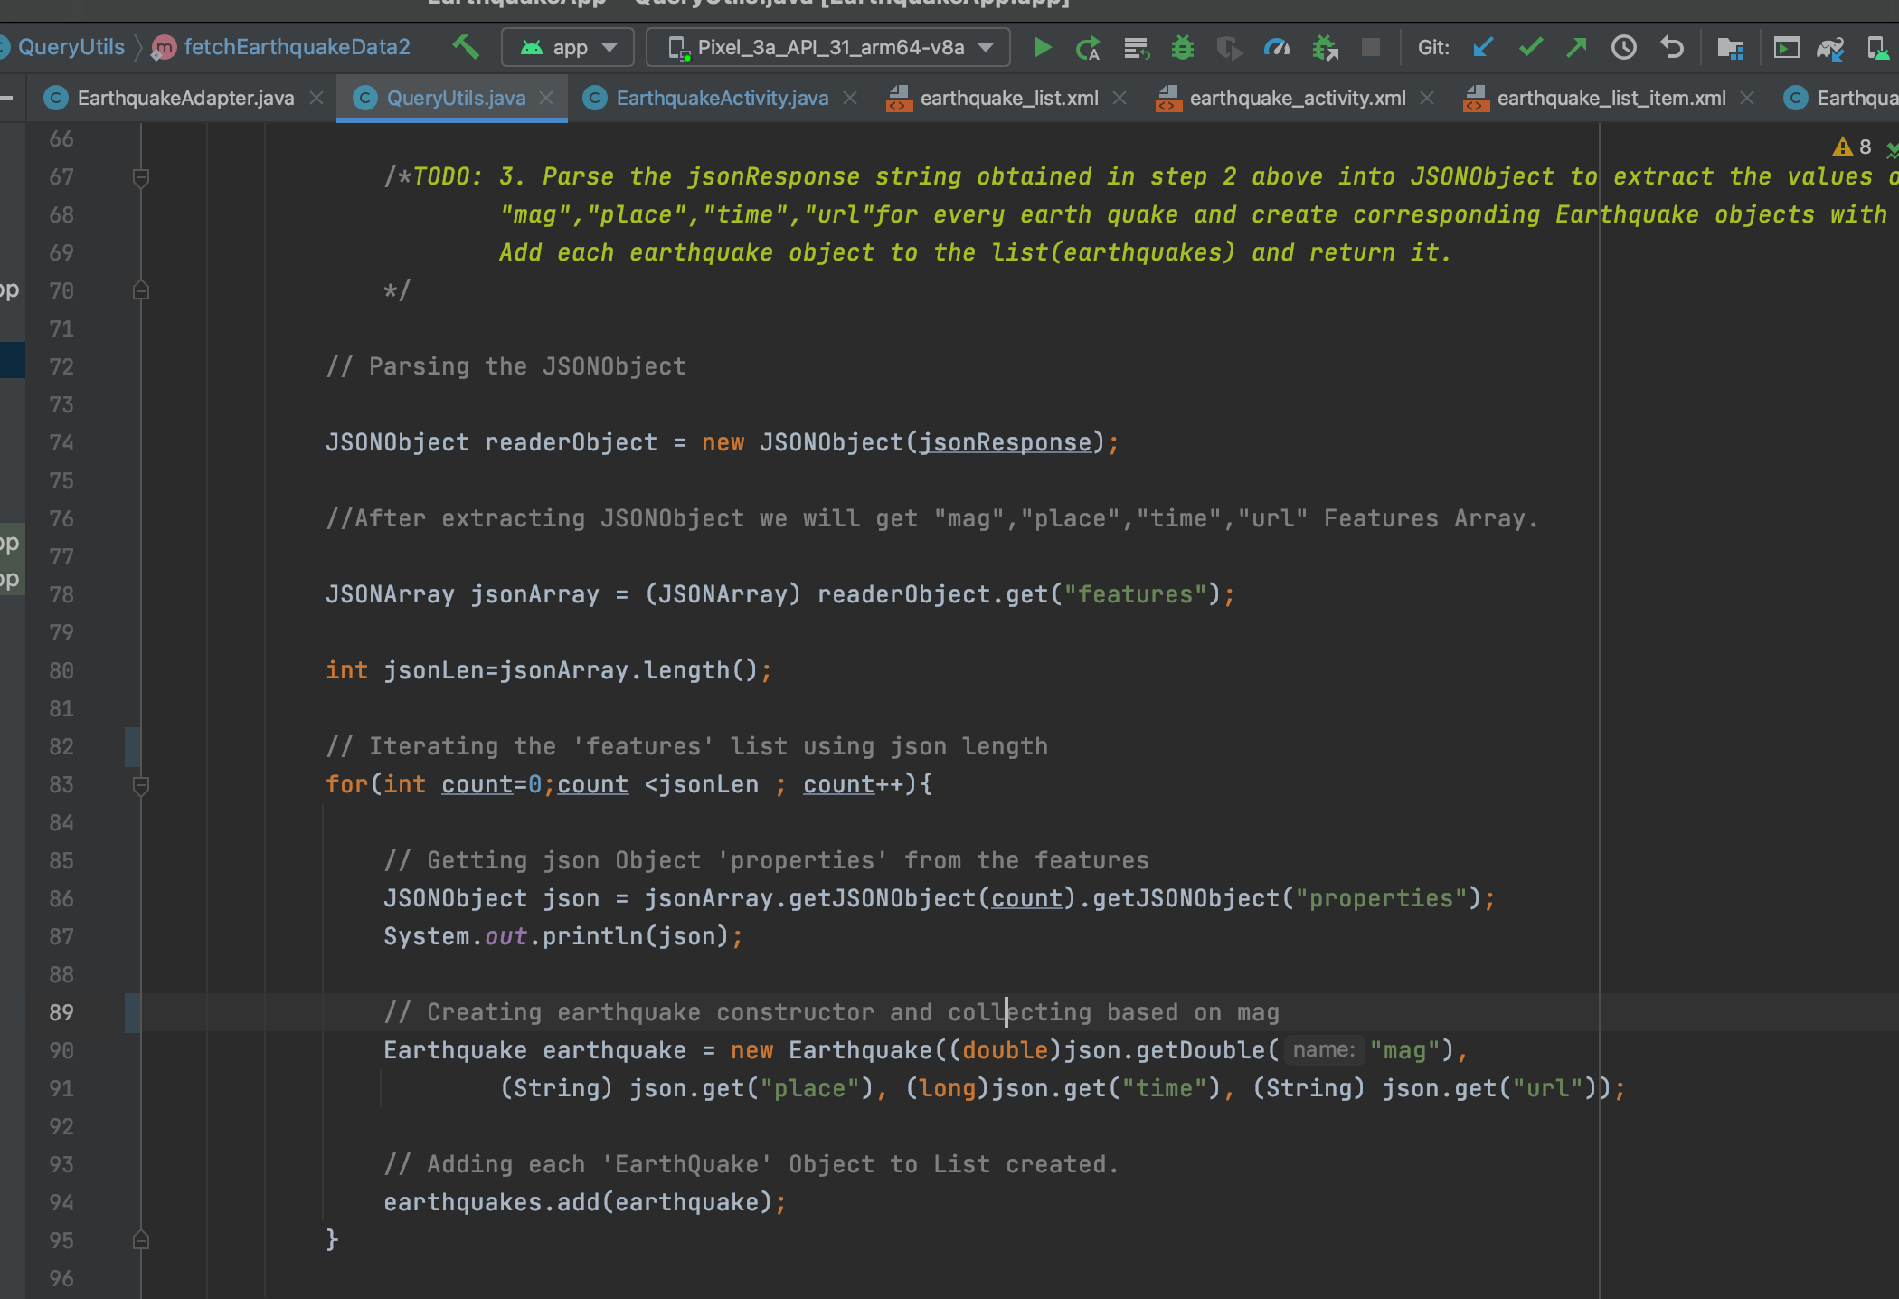

Here these properties came as an array of items. So iterated over this array and created an earthquake item for each iteration.

Each list item is displayed as below:

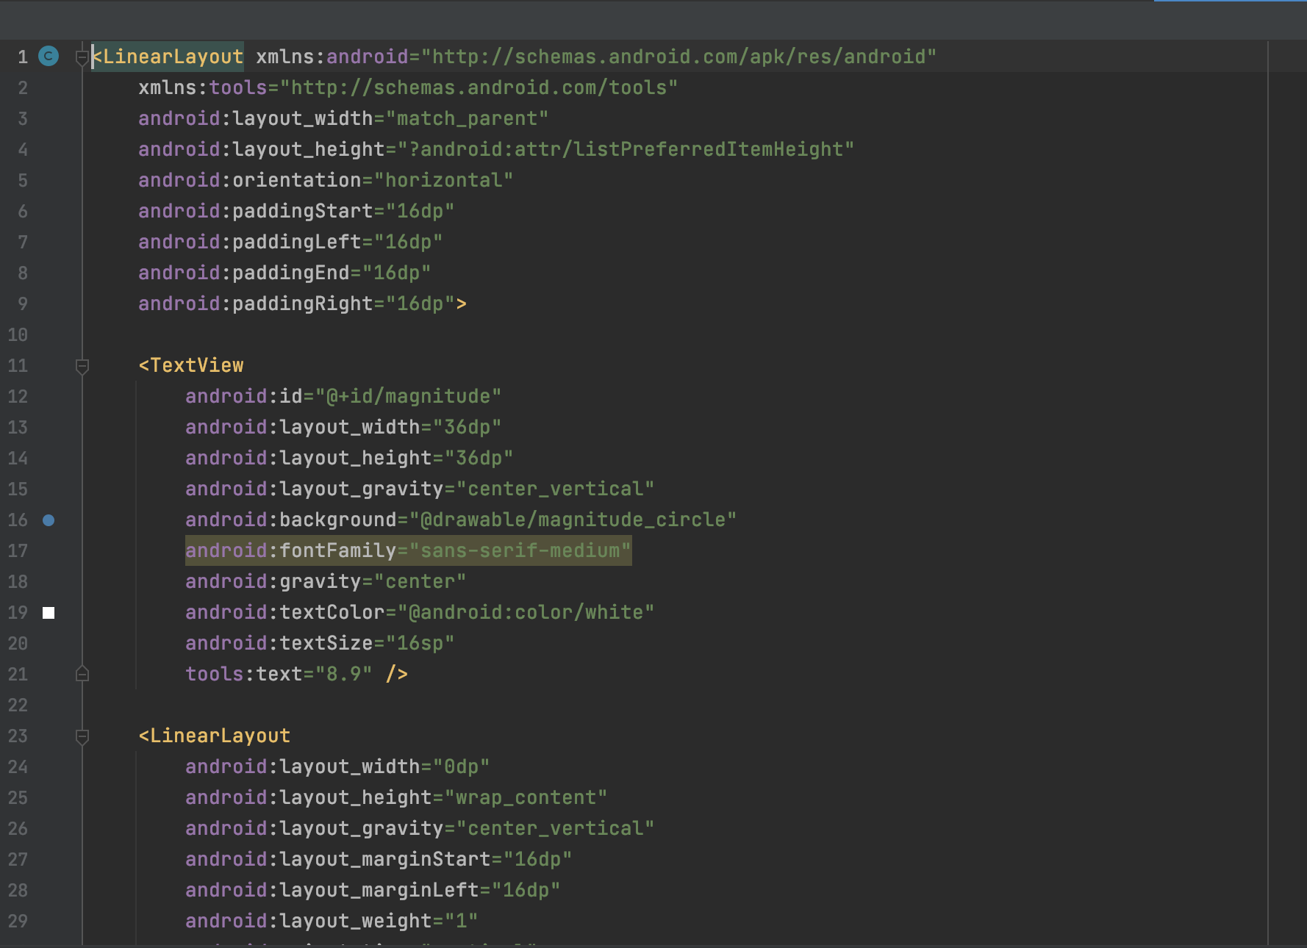

OUTPUT:

In the home page “Eathquake” app is created as below:

Here the app launcher icon is created with an ic_launcher that’s given with the source code.

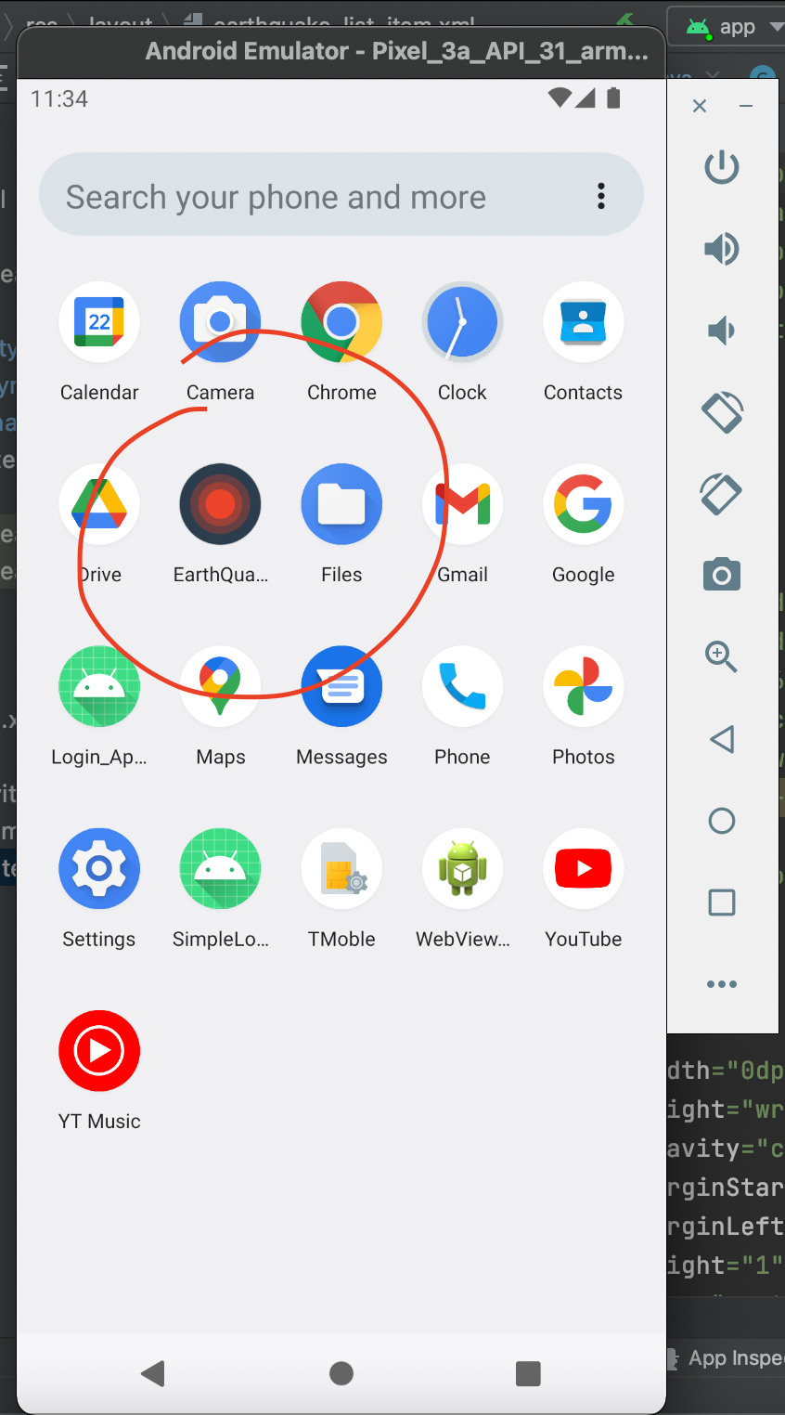

Home page of application is as below: List of items are as displayed below

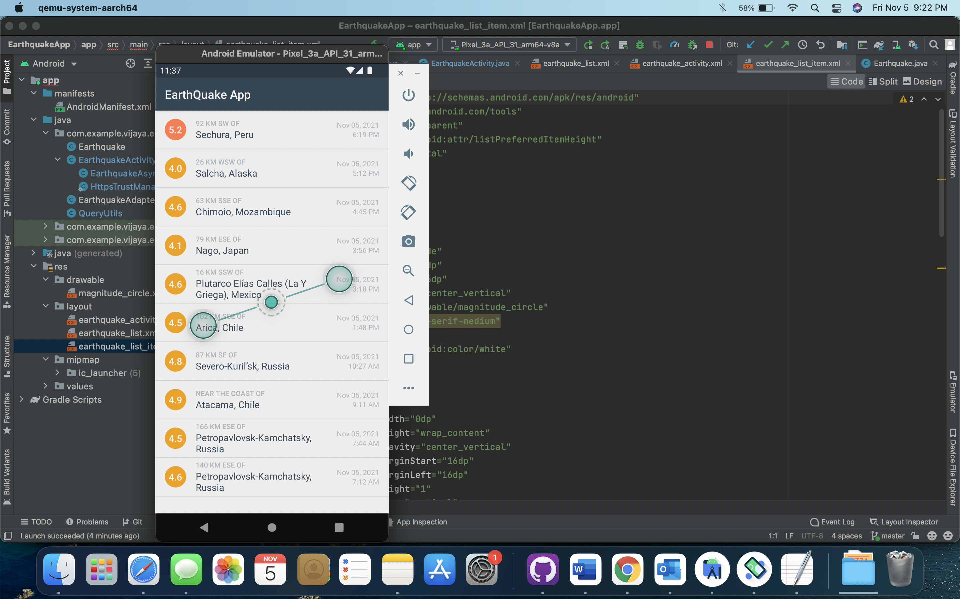

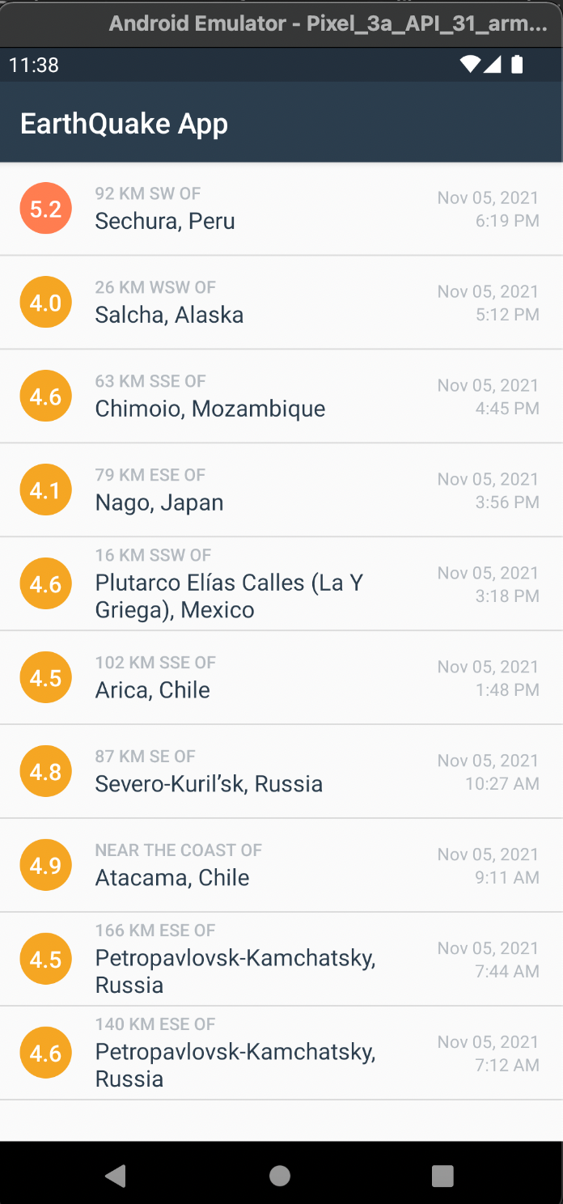

On click of any list item corresponding view will be displayed from the earthquake adapter.

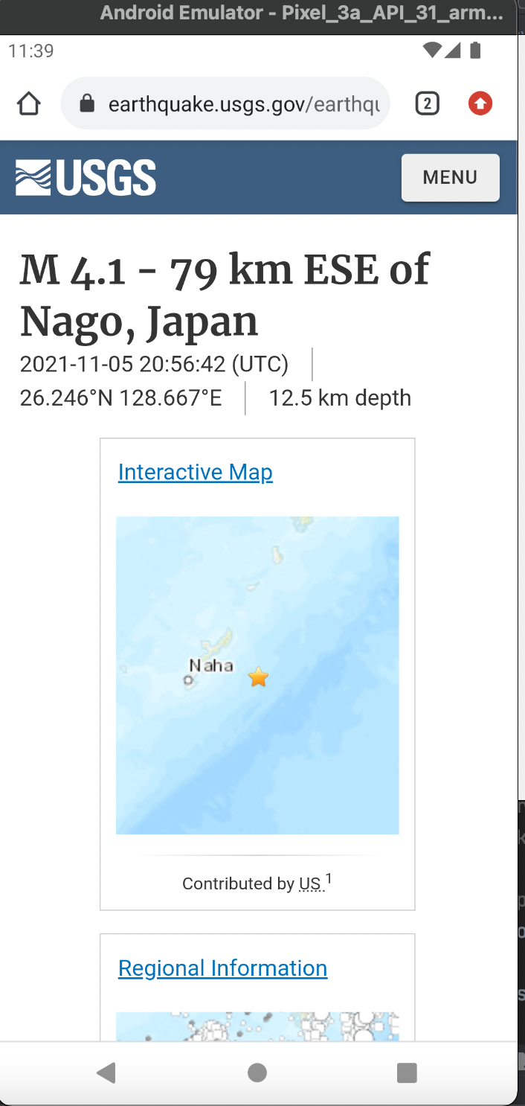

As shown in the above, intent will be displayed in the web browser by loading the activity.

With this ICP is finished with all the necessary enhancements implementations. We learnt about the multi threading and making the network calls using the async tasks.

Thank you.